Python Programming Assignments:

Submitted by:

Hari Prakash D (ID: 14313)
Batch: PPMCAD B17A
-------------------------------------------------------------------------------------------------------------------------------

Q1. ATM Withdrawal System

Code:
"""
---------------------------------------------------------------
Author: Hari Prakash D (ID: 14313, Batch-17A)
Date: 13-APR-2026
---------------------------------------------------------------

ATM Withdrawal System
A simple ATM withdrawal system in Python. The system should allow users to input the amount they wish to withdraw and
check if the withdrawal is valid based on the following conditions:
1. The withdrawal amount must be greater than 0.
2. The withdrawal amount must be a multiple of 500.
3. Account balance must be sufficient for withdrawal.

"""

# Initial account balance
account_balance = 5000

def atm_withdrawal(withdrawal_amount, current_balance):
if withdrawal_amount <= 0:
print("Error: Withdrawal amount must be greater than 0")
return False

if withdrawal_amount % 500 != 0:
print("Error: Withdrawal amount must be a multiple of 500")
return False

if withdrawal_amount > current_balance:
print(f"Error: Insufficient balance. Available: {current_balance}")
return False
else:
current_balance -= withdrawal_amount
print(f"Withdrawal successful. Amount: {withdrawal_amount}")
print(f"Remaining balance: {current_balance}")
return True

# Get user input for withdrawal amount
amount = int(input("Enter the amount to withdraw: "))
# Perform the withdrawal operation
result = atm_withdrawal(amount, account_balance)
print("Transaction result:", result)
print("Transaction completed. Thank you for using our ATM service.")

Output:
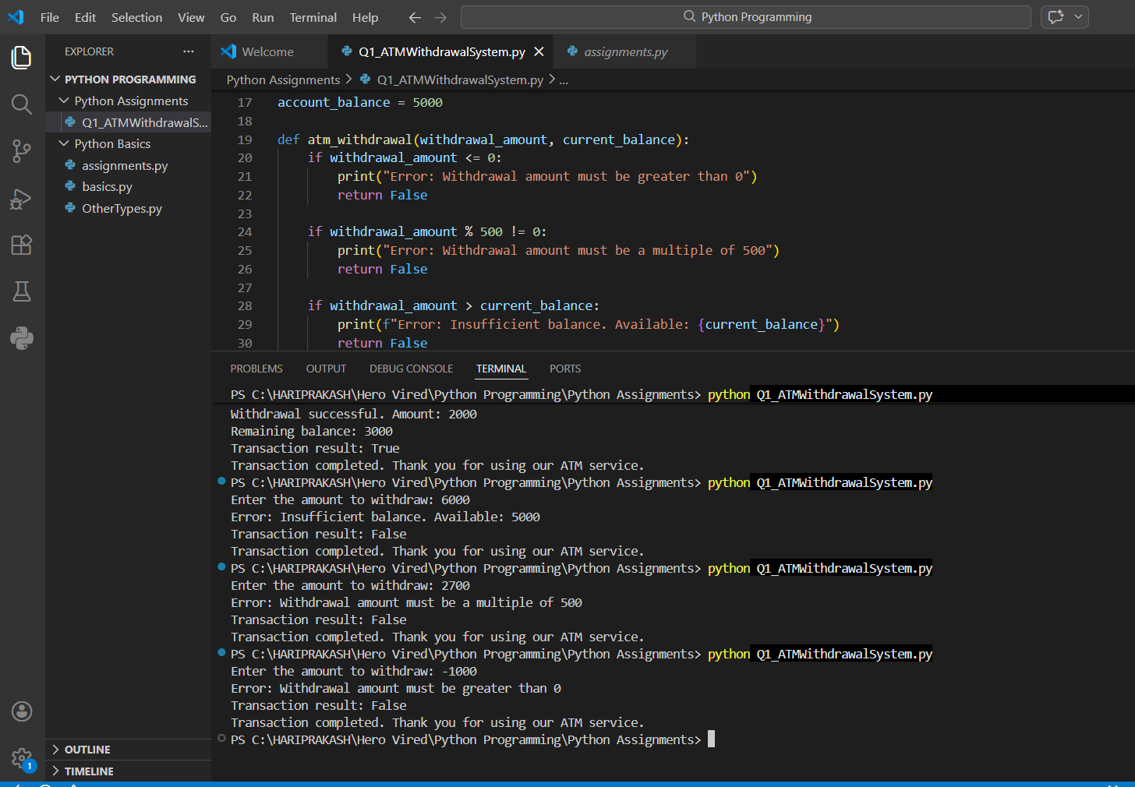

Q1. Restaurant Bill Calculator

Code:
"""
---------------------------------------------------------------
Author: Hari Prakash D (ID: 14313, Batch-17A)
Date: 13-APR-2026
---------------------------------------------------------------

Restaurant Bill Calculator:

Write a Python program that calculates the total restaurant bill including service charge, tax, and tip.
The program should:
1. Take the meal cost as input from the user.
2. Tip is fixed at 5% of the meal cost.
3. Service Charge: 10% of meal cost
4. Amount after Service: Meal cost + Service charge
5. Tax: 5% of amount after service
6. Tip: 5% of amount after service
7. Total Bill: Amount after service + Tax + Tip

"""

# Function to calculate the total bill
def calculate_total_bill(meal_cost):
service_charge = 0.10 * meal_cost
amount_after_service = meal_cost + service_charge
tax = 0.05 * amount_after_service
tip = 0.05 * amount_after_service
total_bill = amount_after_service + tax + tip

print(f"Meal Cost: {meal_cost}")
print(f"Service Charge (10%): {service_charge:.2f}")
print(f"Amount after Service: {amount_after_service:.2f}")
print(f"Tax (5%): {tax:.2f}")
print(f"Tip (5%): {tip:.2f}")
print(f"Total Bill: {total_bill:.2f}")

return total_bill

# Get user input for meal cost
meal_cost = float(input("Enter the meal cost: "))
# Calculate the total bill
total_bill = calculate_total_bill(meal_cost)
# Print the total bill
print(f"Return: {total_bill:.2f}")

Output:
